Teammates: Sameer Basha Md H, Brendan Gillow, Chandra Kiran Challamalasetti
Customer Sales Database System - Lab
School of Professional Studies, Saint Louis University
Information Retrieval (AA-5100-21)
Professor: Tim Toennies
Due Date: May 11th, 2025

Sales Management System Database Design and Implementation

Project Overview:
The Sales Management System is designed to manage and track sales-related information including customers, orders, items, and salespersons. This project implements a normalized database in SQL Server, integrated with Python for data entry and visualization. The system also provides business insights through structured views and analytical visualizations.

2. Objectives:
1. To design and implement a normalized database in SQL Server.
2. To capture sales information efficiently.
3. To integrate Python for data insertion and visualization.
4. To create business views for reporting and analysis.

Database Design:
Entity Relationship Diagram
The database is designed in Third Normal Form (3NF) with four main tables:

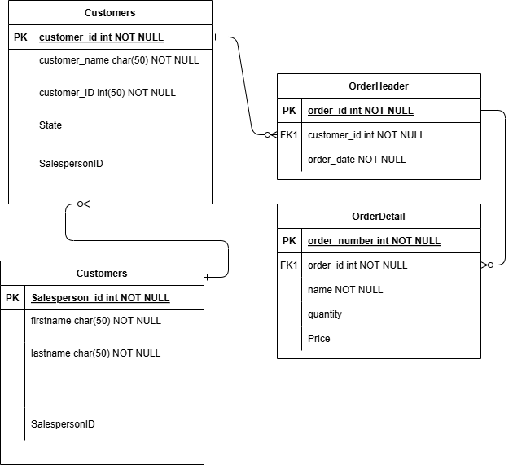Fig 1: Entity Relationship Diagram
The database is normalized to 3NF:
1. 1NF: Atomic values in each field.
2. 2NF: No partial dependencies (non-key attributes depend on the whole primary key).
3. 3NF: No transitive dependencies (non-key attributes do not depend on other non-key attributes).

Table Structure Details:
- SalesPerson Table
  - Primary Key: SalesPersonID (INT)
  - Columns: FirstName (VARCHAR), LastName (VARCHAR)
  - Purpose: Stores information about sales representatives
- Customer Table
  - Primary Key: CustomerID (INT)
  - Foreign Key: SalesPersonID references SalesPerson table
  - Columns: Name (VARCHAR), State (CHAR)
  - Purpose: Stores customer information and links to their assigned sales representative
- OrderHeader Table
  - Primary Key: OrderNumber (INT)
  - Foreign Key: CustomerID references Customer table
  - Columns: OrderDate (DATE)
  - Purpose: Stores general order information and links to customer
- OrderDetail Table
  - Primary Key: DetailID (INT)
  - Foreign Key: OrderNumber references OrderHeader table
  - Columns: ItemName (VARCHAR), Quantity (INT), Price (DECIMAL)
  - Purpose: Stores detailed line items for each order

Python Implementation:

Data Insertion:
A Python script was developed to programmatically insert data into the database tables:
- Creates 25 salespersons with unique identifiers
- Creates 25 customers, each assigned to a sales person
- Creates 25 order headers, one for each customer
- Creates multiple order details for each order with varying quantities and prices

Data Visualization:
Two key visualizations were created:
- Sales by Customer: A horizontal bar chart showing total sales for each customer
- Sales by State: Two visualizations (pie chart and bar chart) showing the distribution of sales by state
Additionally, a top products visualization was created to show the most popular items.

How to Run:

Setting Up the Database:
- Run the SQL DDL statements to create the database schema
- Execute the DML statements to populate initial data (or use Python script)
- Test the function and stored procedure functionality

Using the Python Scripts:
- Update the connection string with your SQL Server details
- Run the data insertion script if starting with an empty database
- Run the visualization script to generate charts and graphs

Conclusion:
The Sales Management System effectively organizes and tracks sales data. Using SQL for data storage and Python for data entry and visualization ensures efficient management and analysis. The system provides insights through structured views and graphical reports, aiding decision-making processes.

References:
- Coronel, C., & Morris, S. (2018). Database Systems: Design, Implementation, & Management (13th ed.). Cengage Learning.
- Matplotlib and Seaborn for Data Visualization.
- Python Official Documentation.
- SQL Server Documentation.

